

test ja

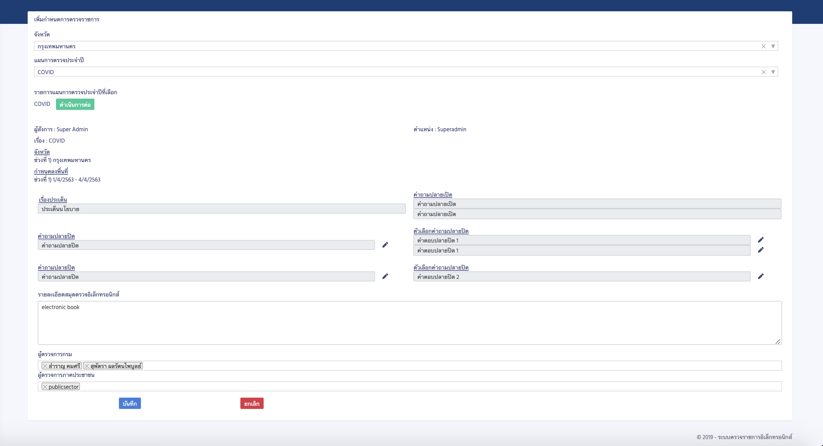

test result 6

EKOKWXE4M6Screen Shot 2563-04-23 at 10.27.10.pnglogo01.png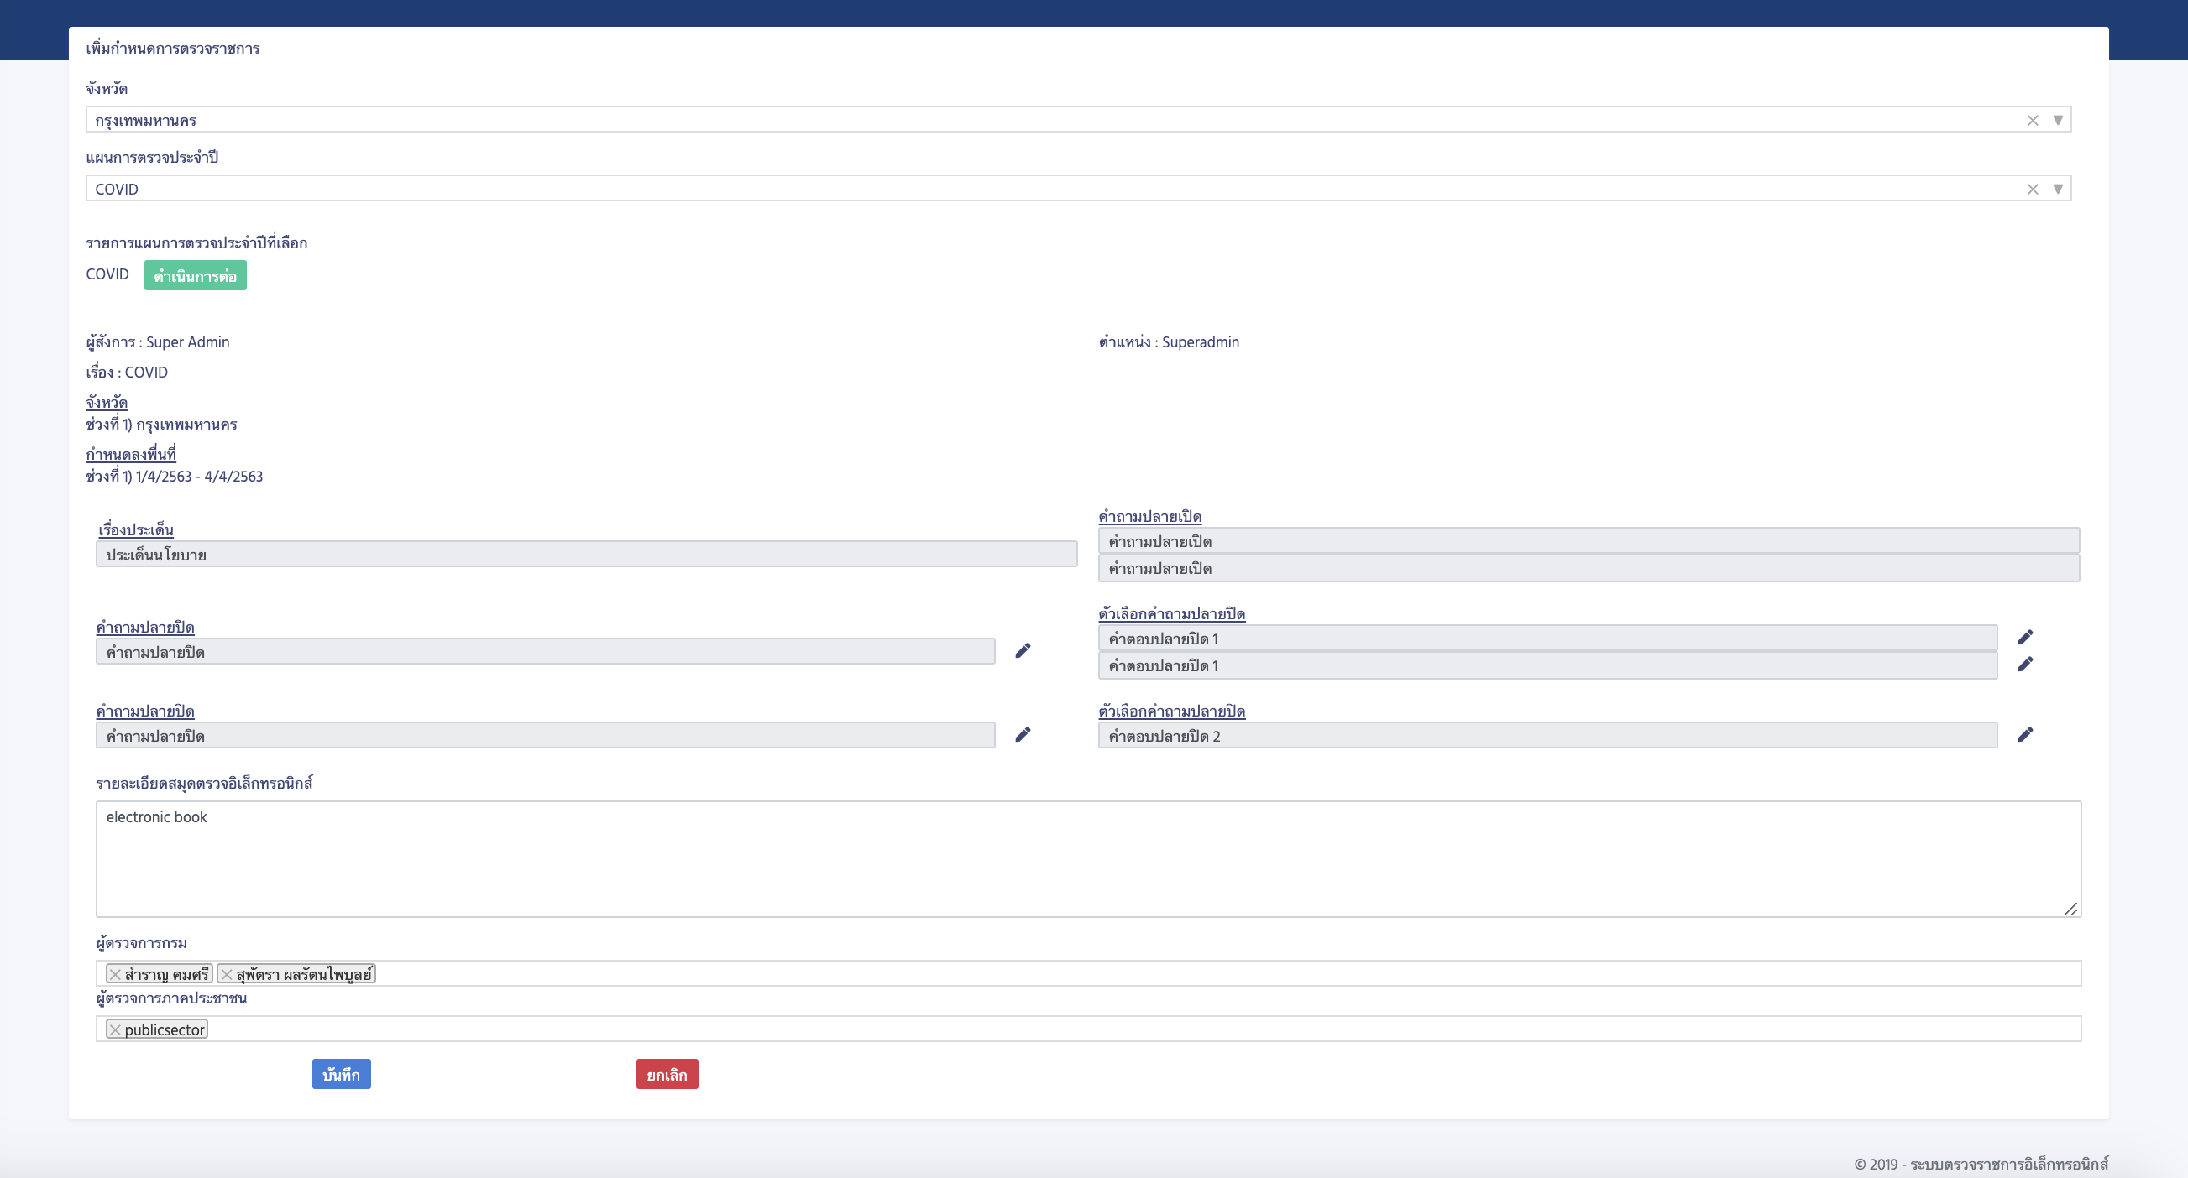TCOQGMA2CMScreen Shot 2563-04-23 at 10.27.52.png